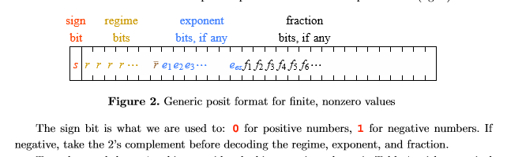

calculate num1*num2+num3

Expo_numo_3

isZero_3

isZero_2

Unum1_shift

Unum2_shift

isZero_1

NaN_3

isInf_3

NaN_2

isInf_2

Expo_num1

Expo_num2

temp1_2

temp2_2

isInf_1

num2

num1

Num3

If num1 or num2 is negative, change it into 2’s complement (required by the format). Check whether they are zero (store in isZero). Check whether one of them is infinite. If one of them is infinite, set isInf to 1.

Use LZC(leading zero counter) to get the length of regime bits

isZero3_1

isInf3_1

Unum3_shift

Temp3

Temp1

temp2

Leftshift three numbers to make exponent bits and fraction bits in certain position.

Calculate the exponent values (in 2’s complement) by using exponent bits and the length of regimes bits

Temp3_2

Expo_num3_3

isZero3_2

Multiple two fractions (product will be in signed magnitude), add two exponent values. Calculate the difference between expo_num3 and exponent of product (exponent value1+ exponent value2-exponent value3). The difference can be positive or negative.

In order to make the working frequency higher, multiplication of fractions will take two clock cycles. The multiplication is done in the frac_mult module

Calculate the sign of product

Frac_num3_3

Expo_diff

Frac_mult module

Frac_numo_3

If the difference of exponent value is negative, change it to positive. (2’s complement to signed magnitude)

Expo_numo_4

Frac_numo_4

Frac_mult module

Frac_num3_4

Expo_diff_4

isInf_4

NaN_4

Right shift the fraction of product or fraction of num3 following the difference of exponent value

Expo_numo_4

isInf_4

NaN_4

Frac_numo_4

Frac_mult module

Frac_num3_4

Expo_diff_4

NaN_5

isInf_5

Expo_numo_5

Frac_numo_5

Frac_num3_5

First step of adding two fractions (in signed magnitude),

Use LZA (leading zero anticipator) to estimate the amount of shift

The addition of fractions in adder is finished in 1 clock cycle in signed magnitude because I can know the which number (num1 or num2) has a greater absolute value in adder module. But for the number3 and product in this module, I cannot compare. So I have to change them into 1’s complement, calculate and changed back, so it will take 2 clock cycles

shift

NaN_6

isInf_6

Expo_numo_6

Frac_numo_6

Do the second step of the addiction. Use LZC to get the amount of shift.

Calculate the result of exponent value by using the larger value between exponent value3 and (exponent value 1+2) and the result of LZC

Shift_7

Normalize the fraction bits

NaN_8

isInf_8

NaN_7

isInf_7

Expo_numo_8

Frac_numo_8

Frac_numo_7

Expo_numo_7

LZA(leading zero anticipator) is designed based on *Leading-zero anticipator (LZA) in the IBM RISC System/6000 floating-point execution unit* (http://ieeexplore.ieee.org/document/5389860/)

Internal multipliers of FPGA are used to do the multiplication of fraction bits.

LZC(leading zero counter) module is designed based on MODULAR DESIGN OF FAST LEADING ZEROS COUNTING CIRCUIT (http://iris.elf.stuba.sk/JEEEC/data/pdf/6_115-05.pdf)

manipulate overflow, underflow, rounding and negative number

Right shift the exponent bits and fraction bits following the regime value (in order to adding regime bits on the left side)

Unumo_10

round

NaN_8

isInf_9

Frac_numo_9

NaN_8

isInf_8

Expo_numo_8

Frac_numo_8